ExNo:12 //JS ALERT BOX

PROGRAM:

<html>

<body>

<center><p><b><u>Alert Box In JavaScript</u></b></p>

<button onclick="myFunction()">Click it</button></center>

<script>

function myFunction() {

alert("This is a alert box!..");

}

</script>

</body>

</html>

OUTPUT:

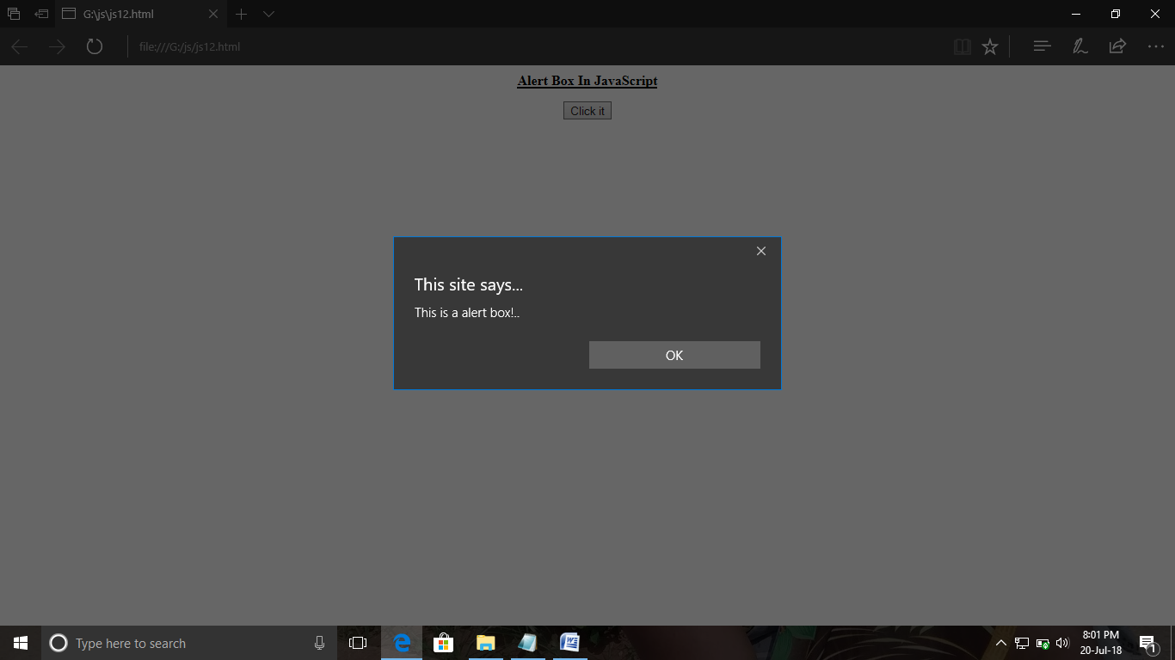

ExNo:13 //JS CONFIRM BOX

PROGRAM:

<html>

<body>

<center>

<p><b><u>Confirm Box In Javascript</u></b></p>

<button onclick="myFunction()">Click</button>

<p id="san"></p>

<script>

function myFunction() {

var txt;

if (confirm("Click the button!"))

{

txt = "You Click OK!...";

}

else {

txt = "You Click Cancel!...";

}

document.getElementById("san").innerHTML = txt;

}

</script>

</center>

</body>

</html>

OUTPUT:

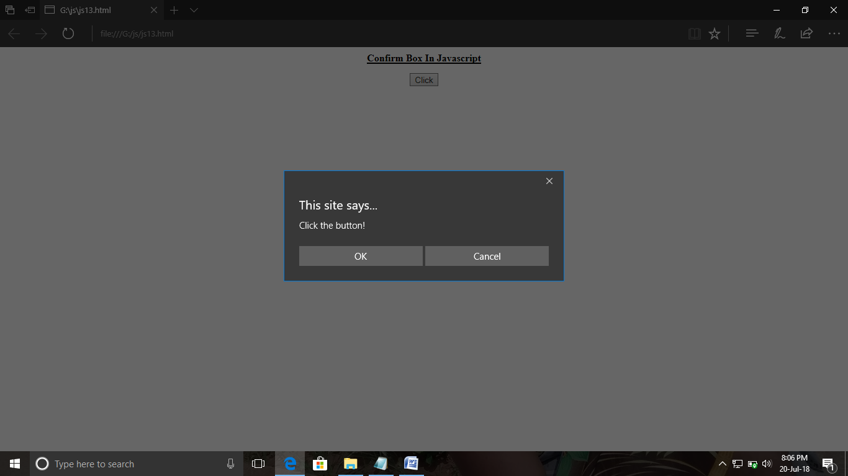

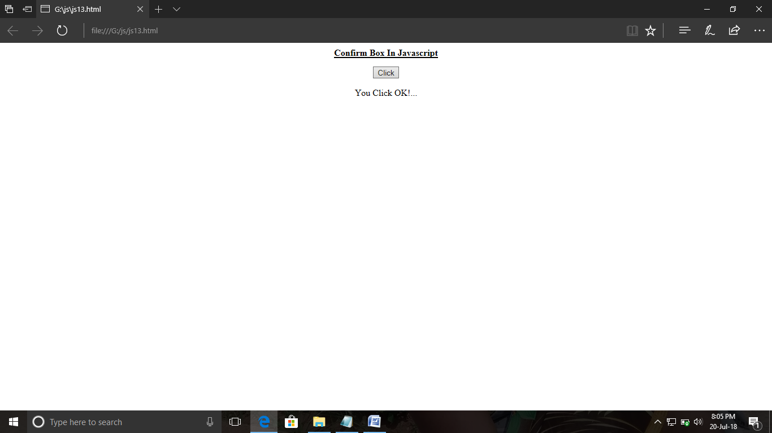

ExNo:14 //JS PROMPT

PROGRAM:

<html>

<body>

<center>

<p><b>Prompt Using JavaScript </b></p>

<button onclick="myFunction()">Click</button>

<p id="demo"></p>

<script>

function myFunction()

{

var txt;

var person = prompt("Please enter your name:", "DINESH KUMAR..M");

if (person == null || person == "")

{

txt = "User cancelled the prompt."; }

else {

txt = "Hi " + person + "! Have A Nice Day "; }

document.getElementById("demo").innerHTML = txt;

}

</script>

</center>

</body>

</html>

OUTPUT:

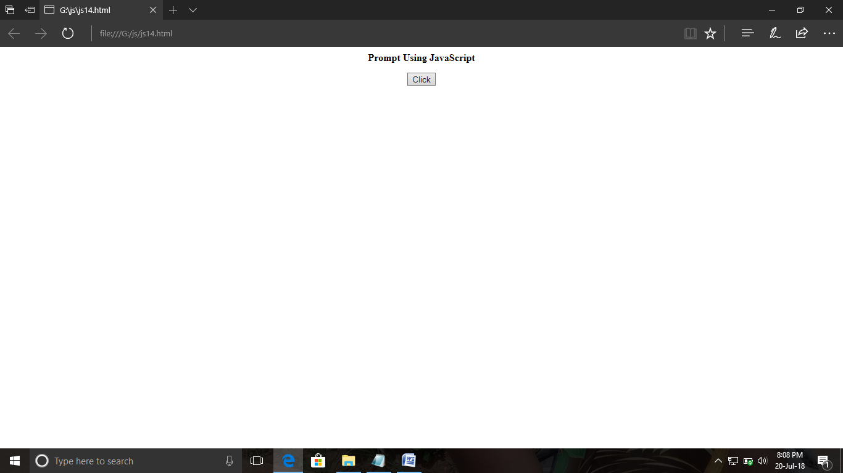

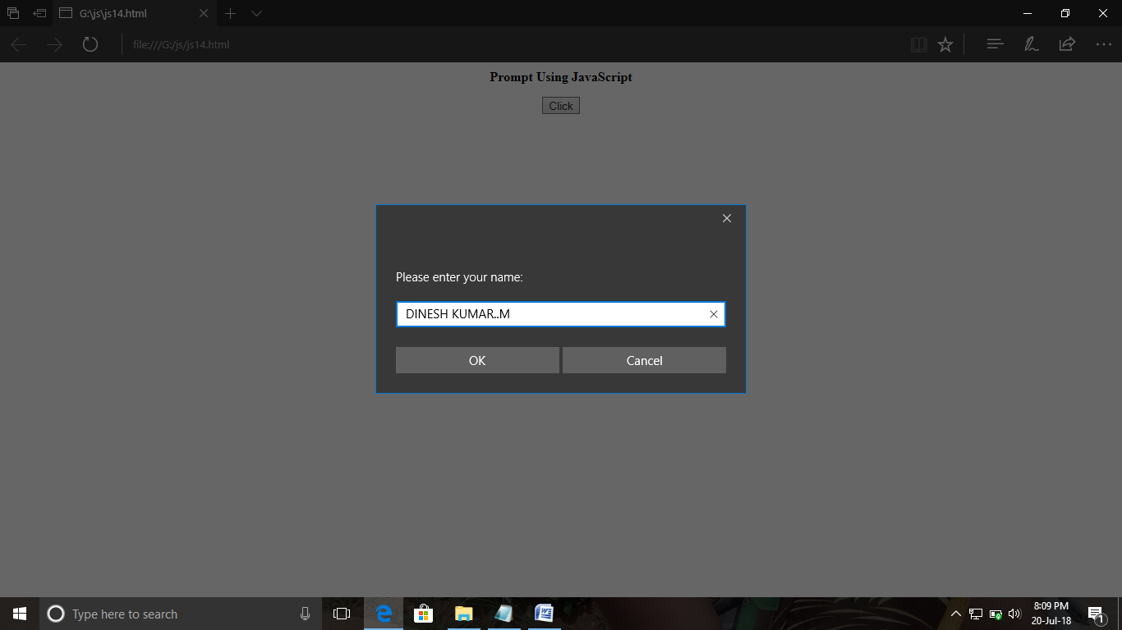

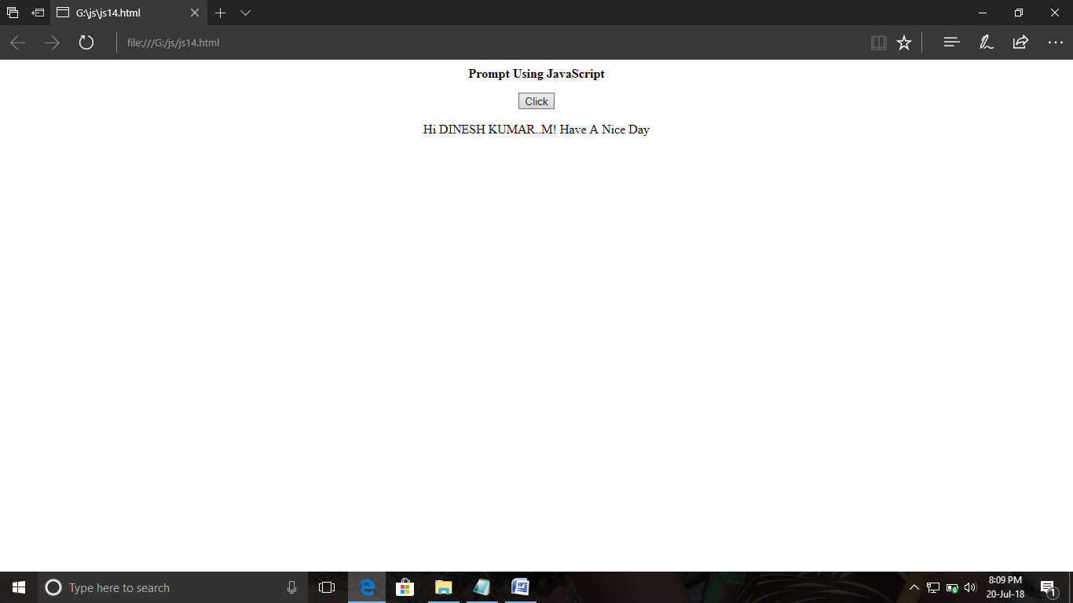

ExNo:15 //JS PRINT

PROGRAM:

<html>

<body>

<center>

<p>IF YOU CLICK THE BUTTON,IT WILL PRINT THE CURRENT PAGE...</p>

<button onclick="myFunction()">Click</button>

<script>

function myFunction()

{

window.print();

}

</script>

</center>

</body>

</html>

OUTPUT:

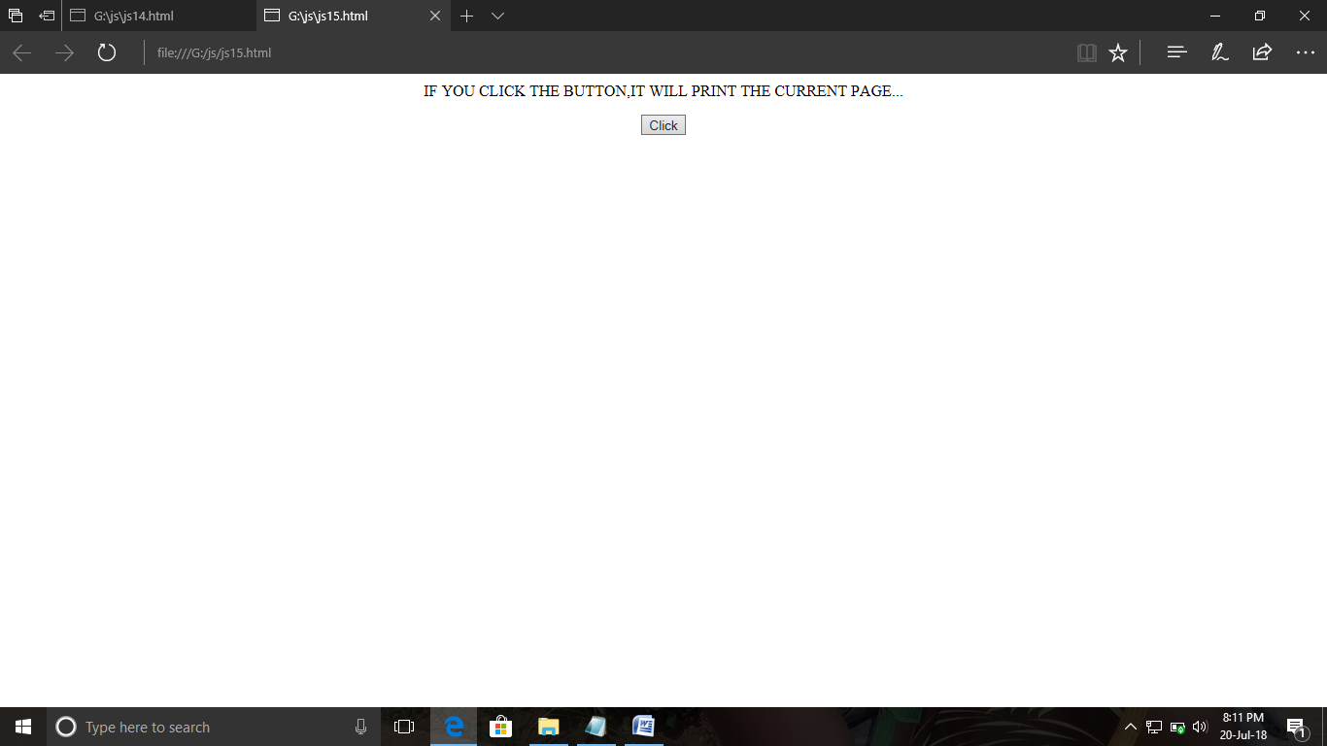

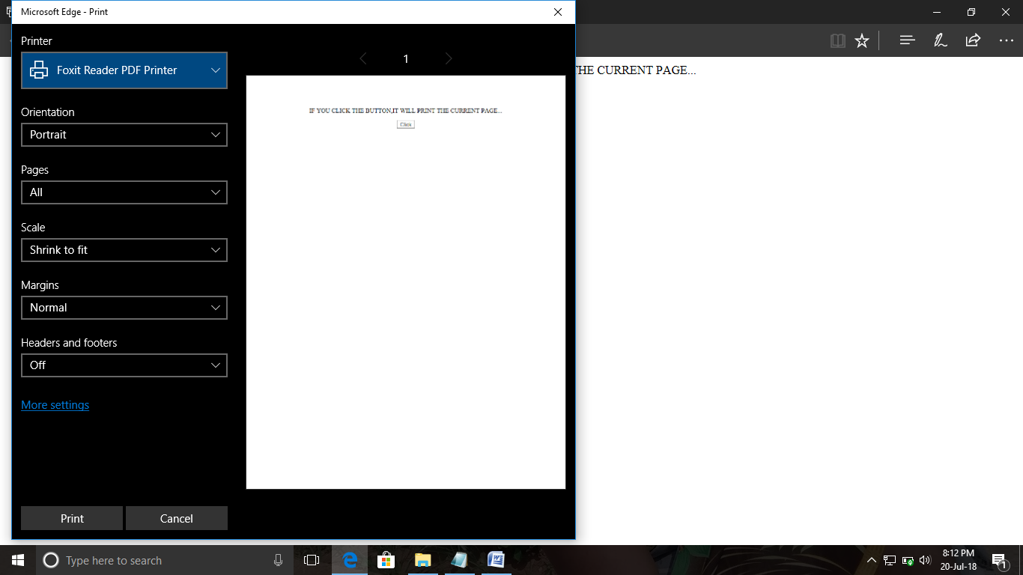

ExNo:16 //JS REDIRECT

PROGRAM:

<html>

<head>

<script type="text/javascript">

function loadNewDoc()

{

window.location="https://github.com/DineshMuruganL";

}

</script>

</head>

<body onLoad="setTimeout('loadNewDoc()', 5000)">

<center><h3><i><b>some amount of time the page will go to my gitup page....</b></i></h3></center>

</body>

</html>

OUTPUT:

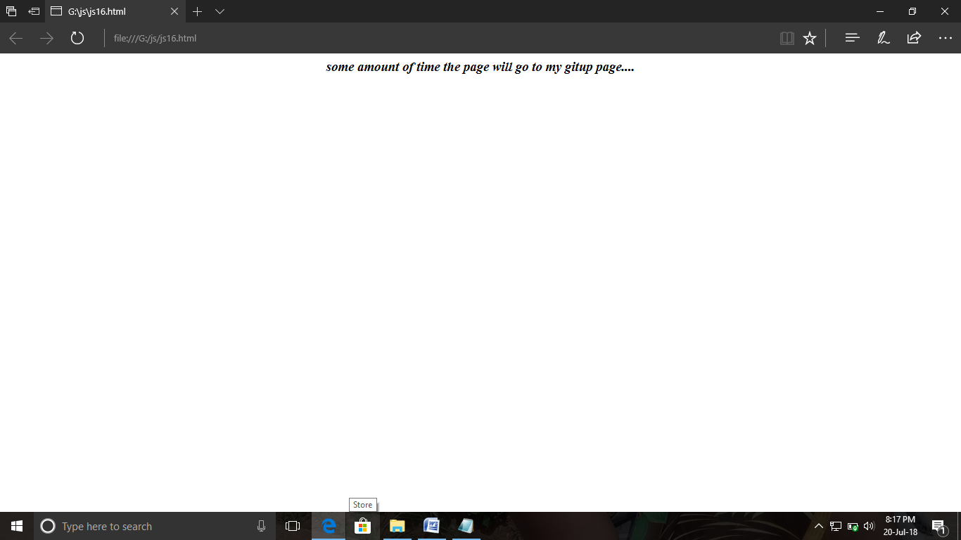

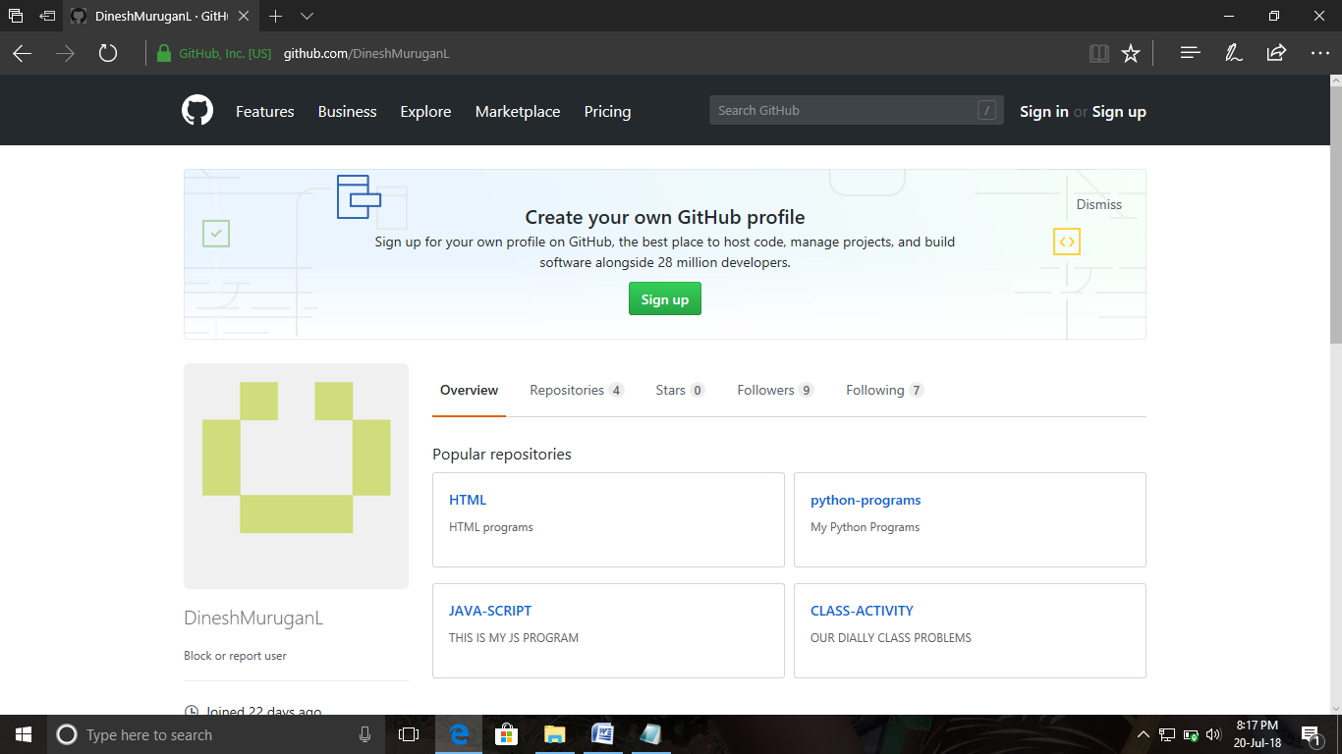

ExNo:17 //JS POPUP BOX TO GO ANOTHER WEB PAGE

PROGRAM:

<html>

<body>

<center>

<p>Click the button ..it will go to my gitup account.</p>

<button onclick="myFunction()">Click here</button>

<script>

function myFunction() {

window.open("https://github.com/DineshMuruganL"); }

</script>

</center>

</body>

</html>

OUTPUT:

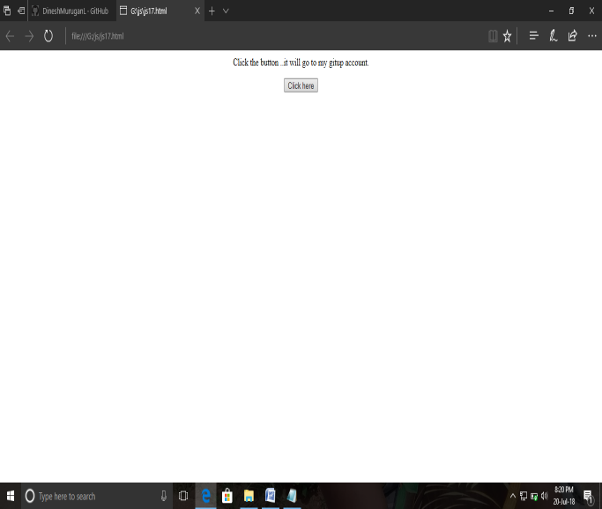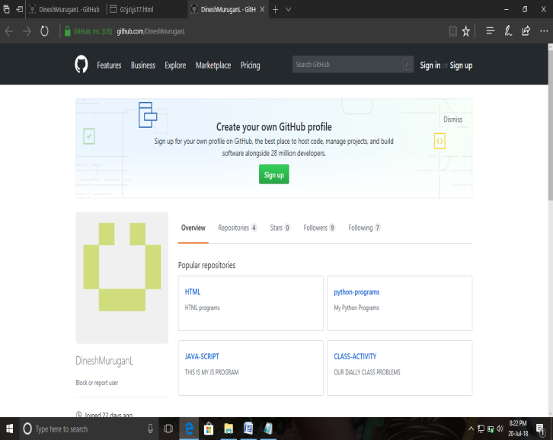

ExNo:18 //JS DATE AND TIME

PROGRAM:

<html>

<body>

<h2>Current Date And Time()</h2>

<p id="demo"></p>

<script>

var mu= new Date();

mu.setMonth(6);

document.getElementById("demo").innerHTML = mu;

</script>

</body>

</html>

OUTPUT:

